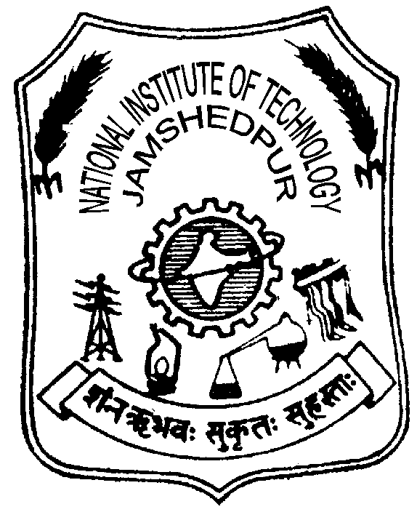 | NATIONAL INSTITUTE OF TECHNOLOGY JAMSHEDPUR JHARKHAND - 831014  (An Institution of National Importance under MHRD, Government of India)  Advt. No. NITJSR/ESTT/829/2013 Date 12/07/2013

Walk-In-Interview for Ad Hoc Faculty

INFORMATION BROCHURE
- ABOUT THE INSTITUTE
National Institute of Technology Jamshedpur is one of the National Importance Institutions for Technical Education in India. This was formerly known as Regional Institute of Technology Jamshedpur. National Institute of Technology (NIT) Jamshedpur is an Institution of National Importance set up by an Act of Parliament (Act 29 of 2007) namely, the National Institutes of Technology Act, 2007, which received the assent of the President of India on the 5th June, 2007. The provision of the Act has come into force with effect from 15th August, 2007 as per Notification S.O.1384 (E) dated 9th August, 2007 of the MHRD (Department of Higher Education), New Delhi. As per the provision of the said Act, this Institution runs on non profitable basis. NIT Jamshedpur offers academic programmes: B.Tech. (Hons.), M.Tech., MCA and Ph.D. in the various disciplines. NIT Jamshedpur has well qualified faculty and dedicated supporting staff.
- Appointment of Ad Hoc Faculty in Department of Humanities
Applications are invited from academic personnel / professionals from Academic Institutes, R&D Labs, and Industry in India or abroad for the Post of Ad Hoc Faculty in Department of Humanities on contract basis for one year (temporary) with consolidated remuneration for effective teaching and commitment to enhance the research activities in the Department and also to teach the following courses.
- English for communication,
- Introduction to soft skills
- Organizational Behaviour & Industrial Psychology
- Industrial Economics & Accountancy
- Industrial Economics

Eligible candidates have to report for walk-in-interview at Computer Centre on 30/07/2013 (Tuesday) at 09.00 AM with original certificates and one set of self attested photocopy of the certificates and two latest passport size colour photographs.

- Appointment of Ad Hoc Faculty in Department of Computer Science and Engineering
Applications are also invited from academic personnel / professionals from Academic Institutes, R&D Labs, and Industry in India or abroad for the Post of Ad Hoc Faculty in Department of Computer Science and Engineering on contract basis for one year (temporary) with consolidated remuneration for effective teaching and commitment to enhance the research activities in the Department and also to teach following courses:
- Operating Systems
- Design and Analysis of Algorithms
- Computer Architecture
- Theory of Computations
- Data Communications
- Real-time Systems
- Complier Design
- Wireless Communications
- Microprocessors and Interfacing / Advanced Microprocessors
- Computer Graphics
- Software Engineering
- AI and Its Applications
- Computer Networks
- Evolutionary Computing / Mobile Computing / Cloud Computing / Grid Computing
- Network Security and Cyber Security
- Embedded systems

Eligible candidates have to report for walk-in-interview at Computer Centre on 10/08/2013 (Saturday) at 09.00 AM with original certificates and one set of self attested photocopy of the certificates and two latest passport size colour photographs.
3. Essential Academic and Professional Qualifications
- For the Department of Humanities and Computer Science and Engineering
Name of the Post | Ad Hoc Faculty
Remuneration in Rs. | Rs. 40,000/- pm (Consolidated)
Age limit | Not exceeding 40 years
Educational and other qualifications required | Essential:  - The person should have Ph.D. degree in the relevant field from reputed Institute with excellent academic record throughout  OR  - The person should have PG degree in the relevant field from reputed Institute with excellent academic record throughout and also 4 years Teaching experience from the reputed Institute

- General Information
- All Qualification, Experience and Age Limit will be recognized as on 30/07/2013.
- Prescribed application form and the summary sheet can be downloaded from the website www.nitjsr.ac.in
- The filled in application form along with original certificates, one set of self attested photocopy of the certificates and two latest passport size colour photographs have to be submitted at the time of Interview.
- Mere eligibility will not vest any right on any candidate for being called for interview. The decision of the Institute in all matters will be final.
- Canvassing in any manner would entail disqualification of the candidature.
- Applications received without complete information / supporting documents will not be considered.
- The candidate will be interviewed only after scrutiny of educational and experience certificates. Hence, it is advisable to carry all the original certificates.
- The experience criteria may be relaxed for exceptionally meritorious candidates.
- The Institute reserves the right to fill or not to fill the post advertised.
- In case of any legal dispute the jurisdiction will be limited to Seraikela-Kharsawan court only.
- No TA / DA will be paid for attending the interview.

*********

